Introduction

1. Business Problem

Bruce, my client, is going to open a Thai restaurant in Hong Kong as he thinks that

Thai restaurant would be a profitable business. However, Bruce is a foreigner and

know little about HK locations.

So, he has no idea which district is an ideal place to start his business but he

thinks that population density, Distribution of Thai restaurants (whether there are too

many Thai restaurant in a district) and rent price are the 3 important factors to be

considered.

1. Data section

I will gather 3 area of data:

a) Population density for each district: from wiki

b) Distribution of Thai restaurants

c) Median Rent price: From property seller website.

Also, as Bruce dislike to start his business in some districts, and I will clean the

data:

a) Islands

b) Tai Po

c) Southern

C) Methodology section

* Using Foursquare to know the distribution of Thai restaurant 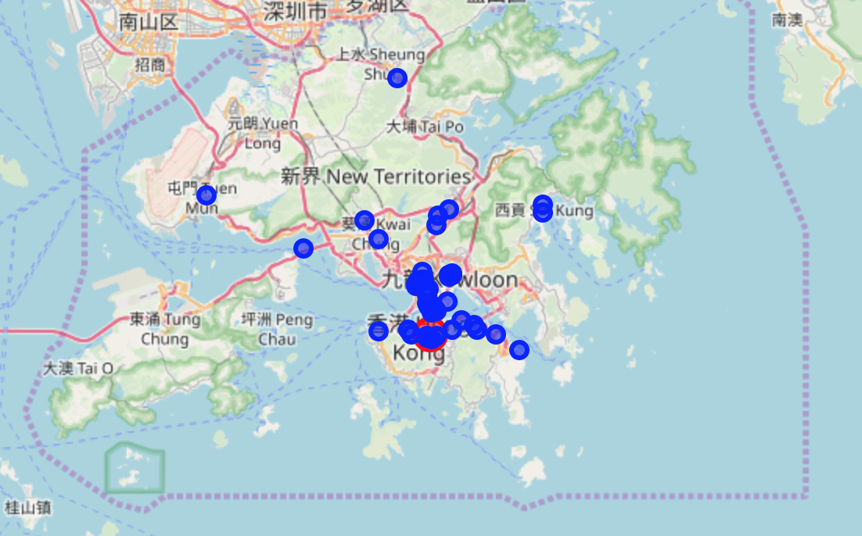
* Using beautiful soup to get district info from wiki

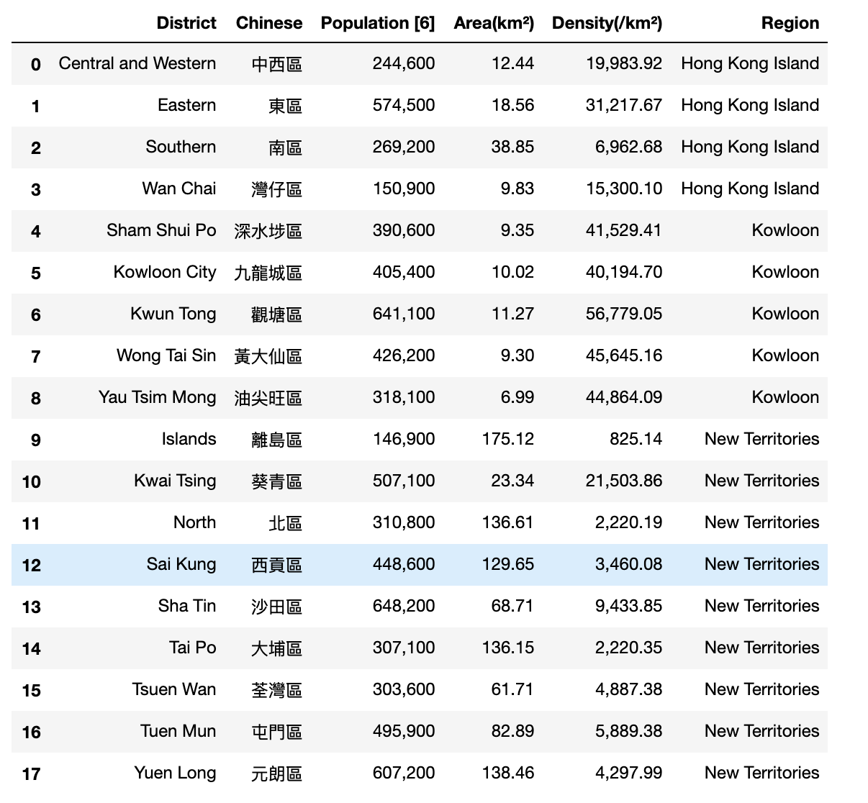

* Using Folium to form a map so that Bruce will know the situation better
* Data cleaning such as dropping columns

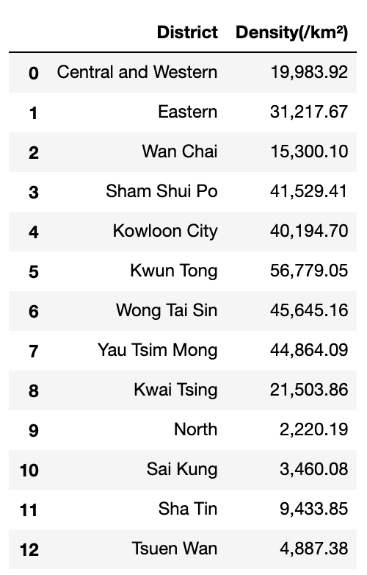

**D) Results section**

The ideal district is Kwai because of its low density of competition, low rent price and high population density.



**E) Discussion section**

I noted that data in Foursquare is not correct, another location database should be used as a reference.

Also, I could include more info, such as median income, rating of Thai restaurant. So that my analysis would be better

**F) Conclusion section**

In this project, I used Wiki and other website to get the information that I needed: rent price and population density. Then, I used Foursqaure to get the distribution of Thai restaurant in order to know more about the density of competition. I also generated a map for Bruce so that he will know all the things better. Finally, I put all the data in a dataframe so that Bruce can choose his ideal place.